Southeast Idaho Wildlife Mitigation Fund

2020 Request for Proposals (RFP) - Guidelines
RFP opens April 17, 2020 and closes at 5:00 pm on May 31, 2020

*Application begins on page 7 below

Please review these guidelines and the supporting attachments. For additional information about the Southeast Idaho Wildlife Mitigation Fund, please visit: http://seidahomitigationfund.com/.

- Background

As part of the U.S. Bureau of Land Management’s (BLM) approval for the Rasmussen Valley phosphate mine, the fertilizer company Itafos Conda LLC, provided nearly $1.2 million to form the Southeast Idaho Wildlife Mitigation Fund (the “Fund”). The Fund was established to offset predicted residual impacts to wildlife and wildlife habitat resulting from the Rasmussen Valley mining operation.

The Fund is managed by an independent, non-profit organization, Sagebrush Steppe Land Trust (SSLT), which convenes a group of natural resource, land management, and Tribal trustees, known as the Habitat Improvement Team (HIT), which includes the Shoshone-Bannock Tribes (SBT), US Forest Service (USFS), US Fish & Wildlife Service (USFWS), BLM, Idaho Department of Fish and Game (IDFG), Idaho Department of Environmental Quality (IDEQ), and the Idaho Department of Lands (IDL). The HIT will select, fund, implement, and assess the effectiveness of approved projects.

- Purpose of the Fund

The purpose of the Fund is to mitigate impacts to wildlife caused by the Rasmussen Valley phosphate mine. Mitigation funds may be used to protect, conserve, and/or enhance wildlife habitat in the project area (Attachment 1), with emphasis on projects in the vicinity of the Rasmussen Valley Mine (HIT bylaws).

The Fund is designed to provide an incentive-based and voluntary partnership opportunity which supports programmatic objectives of HIT agencies through strategic selection of habitat mitigation projects.

- Project Selection
Proposals are reviewed and scored by the Habitat Improvement Team (HIT) through a standardized process (Attachment 2) to evaluate:
- Location of the project in proximity to the Rasmussen Valley mine;
- Funding leverage;
- Habitat enhancement benefits;
- Habitat protection qualities;
- Likelihood of project success;
- Landscape connectivity;
- Lifespan of benefits to wildlife;
- Project monitoring;
- Project feasibility; and,
- Project compatibility with the goals and objectives of each evaluating agency.

- Project Funding
Funding available for the 2020 cycle is approximately $610,000. The Mitigation Fund may be used to purchase conservation easements and for habitat restoration and enhancement including design, materials, construction and management for projects that benefit wildlife and wildlife habitat. If the Proposal involves a conservation easement, the holder of the conservation easement must be qualified to hold conservations easements under federal and state law.

- To Apply

A government entity, tribal nation, non-government organization, corporation/partnership, private landowner or their designee may submit a Proposal.

To apply:
- The project must be located within the Project Area (Attachment 1).
- Applicants must complete the Proposal Form and submit proposals by 5:00 pm on May 31, 2020 to be considered in the current funding cycle.
- Applicants must submit Proposals in electronic format only. The preferred method to submit applications is email and PDF format is preferred.
- Please include the title of your Proposal followed by ‘Mitigation Fund Application’ in the subject line and email Proposals to: matt(at)sagebrushlandtrust(dot)org. If you do not receive a confirmation email within 24 hours or you have any questions about the application process, please contact Matt Lucia at (208) 240-6045.

Hand delivered or mailed Proposals will also be accepted and should be in the form of a CD, USB jump-drive, or other standard media. Please do not send a paper copy or a fax of the Proposal. The CD, USB jump-drive, or other standard media should be clearly labeled with the title of your Proposal followed by ‘Mitigation Fund Application’.

Proposals sent via US Mail, FedEX, or other reputable delivery service:

Attn: Matt Lucia
Sagebrush Steppe Land Trust
P.O. Box 1404
Pocatello, ID 83204.

Hand-deliver Proposals to:
Matt Lucia
Sagebrush Steppe Land Trust
109 N. Arthur Ave., Suite 300

Pocatello, ID 83204

- Additional Information

Proposals will be accepted between April 17th and May 31st. Proposals must be submitted in electronic format only.

The HIT recognizes that maintaining wildlife-compatible agriculture on the landscape is an important benefit that can be realized through appropriately crafted project designs, conservation easements, agreements, management plans, and monitoring protocols. If the project is located on private property, the landowner(s) must sign the Proposal. By signing and submitting the Proposal, landowner(s) acknowledge the Proposal is made willingly by the lawful owner(s) in order to be considered for funding awards.

It is important for the HIT and other funding partners to provide accurate information to the public regarding the Mitigation Fund and efforts to conserve and enhance wildlife habitat. Applicants should be aware that project information and applications will be used by the HIT for internal planning and public information purposes. A summary of each Proposal will be posted on the mitigation fund website, but will not include any personal information of private landowners.

Any request for significant modifications or changes to a Proposal after the Proposal deadline (5:00 pm on May 31st) will not be considered.

The HIT may answer questions and provide guidance during the application process, but will not provide legal advice to applicants. Please direct questions to Matt Lucia at (208) 240-6045.

Please read each question carefully, follow instructions, and answer the questions with detailed, specific, and accurate information in the space provided. Inaccurate or incomplete answers may receive a zero (0) score. Text boxes and lines will automatically expand, as needed, when you type in the space provided.

Applicants should articulate a clear vision of the desired future condition of the Project and its benefits to wildlife in the Proposal. Proposals must include details of follow-up monitoring and/or reporting included in their proposal. Project funding requires each recipient commit to submitting a “post-construction” report within two months of the project completion date affirming that they have completed the project. An outline of verification monitoring, photo-logging and reporting planned for the project must also be included. BLM and IDFG will compile an annual Habitat Performance Report which will summarize how well the funded project(s) have met project mandates.

Proposals are awarded funding based on evaluations and decisions made by the Habitat Improvement Team (HIT). All applicants will be notified of the status of their proposals on June 26th, after the first round of evaluations. Applicants selected in the first round of evaluations will be invited to provide a presentation of their proposal on Thursday, July 9th to the HIT.

Please Note: presentations must be prepared using technology that can be shared via video conference (e.g., Zoom, Google Meet, etc.). The specific time and location will be determined at a later date. Please hold that date until you are notified of the status of your application.

Following the presentation meeting, the HIT will coordinate with applicants and schedule site visits during the week of July 13-17. Applicants or their designees are expected to lead the site tour.

Final award decisions are made by the Habitat Improvement Team (HIT) after a thorough review of the application and site visit. Applicants will be notified of the HIT’s final decisions and projects will be selected for funding by early August. An award letter and grant agreement will be sent to successful applicants immediately following the HIT’s final decisions. Funds will be made available after receipt of the signed grant agreement. See Attachment 3 for a schedule of the Proposal review process and approval dates.

Attachment 1. Project Area Map
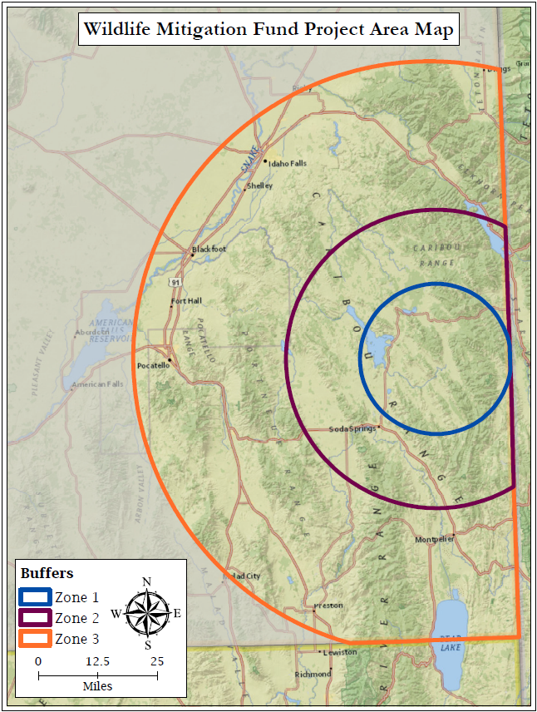

Attachment 2. Project Scoring Matrix (maximum score 175 points).
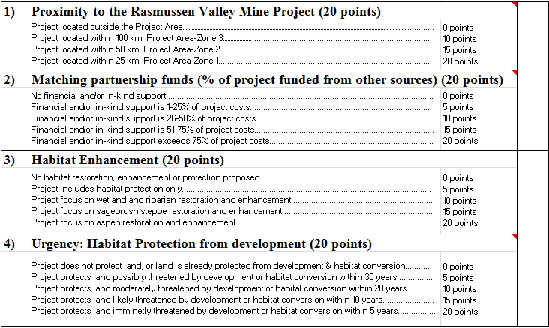
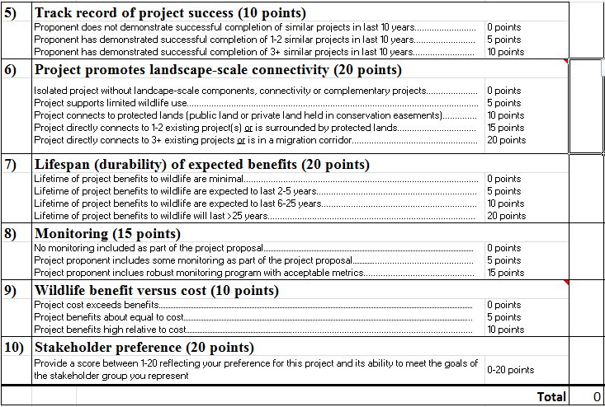
Attachment 3. Timeline.

2020 RFP Timeline
DATE | ACTIVITY
March 20 | Spring HIT Meeting
April 10 | HIT Check-in meeting
April 17 | RFP release and application period opens
May 31 | Deadline for submitting RFP applications
June 05 | Distribute RFP applications to HIT members for scoring with matrix. Post summary of all applications on website
June 25 | First round of HIT scoring & evaluations: Time & location TBD
June 26 | Applicants will be notified of the status of their application. Applicants that remain in consideration will be invited to give a presentation to the HIT on July 09. Presentations must be prepared in a way that can be shared via video conference.
July 09 | Presentations from applicants to HIT and follow-up questions: Time & locations TBD.
July 13-17 | Site visits for 2020 proposals: Time & locations TBD.
By early Aug. | HIT meeting to select project(s) for funding awards. Time & location TBD.
By early Aug. | Applicants will be notified of the status of their application. Successful applicants will receive a grant agreement with instructions for reporting and project completion.

Southeast Idaho Wildlife Habitat Mitigation Fund

Request for Proposals

2020 Application Form

[Insert a Photograph of the Project Area/Property here]

For the

[Insert Project Title]

Submitted by:

[Insert Applicant Name]

[Insert Date]

Applicant Information
Please provide the following information:

Project Title
Enter the Project Title in the box below. This is the title which is also to be used on the Cover Page above.

Landowner Name(s)
Provide the name(s) of landowner(s), including all individuals, local, state, federal governments, tribal nations, and business entities with ownership interests in the property where the Project is to occur.
1. |  | 4.
2. |  | 5.
3. |  | 6.

Signature of Intent
By signing the bottom of this application, the property owner agrees that the project described below may proceed on the lands identified herein.

D. Applicant Contact Information
Provide information for the applicant that will be contacted for questions about this Project Proposal and notified of decisions.
Name:
Mailing Address:
City, State, & Zip:
Phone Numbers(s):
Email (required):
Agency/Organization (if applicable)

If the applicant is someone other than the landowner, please indicate the relationship of the applicant to the landowner (e.g., Ranch Manager, Habitat Biologist, Project Manager, etc.):

1. Project Overview and Location Information (20 Points)
Please provide the following information:

Project Description
Please provide a detailed and complete description of your project including type of project (e.g., enhancement, restoration, protection, etc.), current habitat conditions on the project site, desired future conditions, start and end dates, project goals, methods to ensure durability of project benefits to habitat, an outline of monitoring, photo-logging and reporting planned for the project, and metrics you will use to evaluate success:

Expected Timeline
Please provide a project timeline (start and end dates) with benchmarks to measure progress:

Wildlife Species
List wildlife species, including special status species (e.g., Federal listed threatened, endangered or candidate species, State Special Concern Species, Species of Greatest Conservation Need, etc.) that are expected to benefit from the Project:

D. Zone
Which zone is the Project located (please refer to the Project Area Map in Attachment 1, above):

E. County
Which County(ies) is the Project located:

F. Location
Please include the survey (if applicable) or UTM coordinates (in Zone 12, NAD 1983 datum) of the Project location. Surveys should be included as an attachment to this Proposal.

Enter the accurate and complete legal description or UTM coordinates of the Project site:

G. Photographs
High resolution photographs of the Project Property are required as attachments to this Proposal in JPEG or other standard viewable format files. Please limit the number of photographs to no more than six (6) high quality images.

Photographs will be published in presentation and printed materials related to the scoring and evaluation process. By submitting this Proposal, the landowner and applicant agree to allow the HIT’s discretionary use of the photographs.

H. Maps
At least two maps are required and must be included with the Proposal. These are:
- Vicinity Map should display identifiable landmarks and show boundaries of the proposed Project area and its relationship to the surrounding landscape. It should also depict the surrounding land ownership (i.e., state, federal, tribal land, other protected lands, and private land).

- Project Map should be a zoomed-in view of the Project location and clearly identify the Project boundaries.

Please note: Applicants are encouraged to submit additional maps as needed and GIS shapefiles of the Project’s geographic boundary. Shapefiles should be projected as UTM Zone 12 in NAD 1983 datum.

2. Funding Request & Leverage Information (20 Points)
Please estimate your funding request carefully and complete the Project Budget Form. In-kind contributions must be described in the revenue source column. Please indicate whether each revenue line item is committed or pending in the Project Budget Form. Project overhead/administration must be listed as its own line item in project expenses. Submit the completed Project Budget Form as an attachment with your Proposal.

Funding Request
What is the total amount requested from the Southeast Idaho Wildlife Mitigation Fund:
$

3. Habitat Restoration & Enhancement (20 Points)

A. Habitat Types and Vegetation Communities
Describe habitat types on the Project site including general composition of vegetation communities and the associated acreage for each community:

Please list any rare plant communities found on the Project site and indicate these locations on the Project Map (if applicable):

B. Aspen Habitat Restoration/Enhancement
Does the Project include aspen habitat restoration or enhancement?
Yes
No
If yes, describe the Project and how it will benefit the wildlife species listed in Section 1:

C. Sagebrush Steppe Habitat Restoration/Enhancement
Does the Project include sagebrush steppe habitat restoration or enhancement?
Yes
No
If yes, describe the Project and how it will benefit the wildlife species listed in Section 1:

Wetlands and Riparian Habitat Restoration/Enhancement
Does the Project include wetlands or riparian habitat restoration or enhancement?
Yes
No
If yes, describe the Project and how it will benefit the wildlife species listed in Section 1:

4. Urgency for Habitat Protection (20 Points)

Threat of Habitat Loss/Degradation
Describe the threats of habitat loss, fragmentation, conversion, and degradation in the surrounding landscape of the Project:

Please select one:
Project does not protect land; or land is already protected from development and habitat conversion.
Project protects land possibly threatened by development or habitat conversion within 30 years
Project protects land moderately threatened by development or habitat conversion within 20 years
Project protects land likely threatened by development or habitat conversion within 10 years
Project protects land imminently threatened by development or habitat conversion within 5 years

Please describe your selection above and cite specific examples:

Is the Project Located on State, Federal Land, or Tribal Land?
Yes
No (if no, skip to C.)
If yes, which entity owns title to the land?

If the project is located on federal land, has NEPA been completed?
Yes
No

If NEPA has been completed, please provide documentation with this proposal. If NEPA has not been completed, please describe when the decision is expected, the plan to complete the process and costs necessary to address NEPA compliance for the proposed project:

If the Project is on State, Federal, or Tribal land, please describe how the Project will reduce or eliminate threats of habitat loss, fragmentation, conversion, and degradation:

Is the Project located on private land?
Yes
No

If the Project is on private land, please describe how the Project will reduce or eliminate threats of habitat loss, fragmentation, conversion, and degradation:

5. Likelihood of Project Success (10 Points)

Project Management
Please identify the Project Manager:

Has the Project Manager demonstrated successful completion of similar projects in the last 10 years?
Yes
No

If yes, please list similar projects, including the year completed, and describe how success was determined and the name and contact number of a reference for each:

B. Project Effectiveness
Is the proposed Project similar to projects that have been proven to be effective at other comparable sites?
Yes
No

Please describe:

6. Landscape Connectivity (20 Points)

A. Ecological Connectivity
Describe the ecological connection of the Project to the surrounding landscape (e.g., wildlife migration corridors, wildlife movement patterns, habitat connectivity, river or tributary connectivity, etc.):

B. Strategic Connectivity
Describe the physical connection of the Project to protected lands (i.e., state, federal, or conservation easement properties):

7. Lifespan of Benefits to Wildlife (20 Points)

A. Durability
Describe the expected lifespan of the Project benefits to wildlife and the protective measures in place to sustain these benefits:

8. Project Monitoring (15 Points)

A. Monitoring Program
Does the Project include a monitoring program or monitoring protocols?
Yes
No
If yes, please describe and include metrics and duration of monitoring program:

9. Project Feasibility (10 Points)

A. Technical Needs
Does the Project require technical expertise or oversight?
Yes
No
Unknown
If yes, please describe the technical resources needed and the general plan for securing technical assistance for the Project:

B. Legal Needs
Does the Project require legal expertise or oversight?
Yes
No
Unknown
If yes, please describe the legal resources needed and the general plan for securing legal advice for the Project:

C. Economic Analysis
Is the Project economically feasible compared to other projects of similar scope and size?
Yes
No
Unknown
If yes, please describe:

10. Stakeholder Preference (20 Points)
A. Public Benefits
How will the public benefit from this Project?

- Conservation Plans
List specific local, state, regional, and federal conservation and management plans supported by this Project (i.e., county Master Plans, county Comprehensive Plans, Species Management or Recovery Plans, State Herd Management Plans, Data Analysis Unit Plans, Conservation Area Plans, etc):

Additional Considerations
Please describe any exceptional circumstances not mentioned above or additional considerations to be included in the evaluation process:

Letters of Support
Is this Proposal supported by any of the following: neighboring landowners, members of the public, private sector, non-government organizations, tribal or government entities?
Yes
No

If yes, please include letters of support as attachments to this Proposal.

Executive Summary
In the box below, please provide a summary of the most salient features of your Project, including the desired future condition and expected benefits to fish and wildlife. The Executive Summary should not exceed 400 words.

Signatures
By typing your name and marking an X in signature box below, you certify that: (1) this application is made voluntarily and that you agree the project can proceed on the land indicated in this application; (2) the information contained in this Proposal is complete and accurate to the best of your knowledge; (3) access to the project will be granted to the Habitat Improvement Team for a site visit prior to final award decisions; (4) if selected for funding, you agree to allow the Habitat Improvement Team access to the Project for initial progress inspection and a completion inspection; (5) if selected for funding, you pledge to work diligently and in good faith to complete the project in the timeframe indicated; and (6) upon completion of the Project, you will provide the HIT with a final report including a summary table of how funds were used.

All private landowners involved in the project must sign. Please copy additional signature blocks, as needed.

Private Landowner(s):
Name of Landowner:
Place an X in box at right to indicate that you intend your typed name to constitute your electronic signature:
Date:

Name of Landowner:
Place an X in box at right to indicate that you intend your typed name to constitute your electronic signature:
Date:

Name of Landowner:
Place an X in box at right to indicate that you intend your typed name to constitute your electronic signature:
Date:

Name of Landowner:
Place an X in box at right to indicate that you intend your typed name to constitute your electronic signature:
Date:

Name of Landowner:
Place an X in box at right to indicate that you intend your typed name to constitute your electronic signature:
Date:

Name of Landowner:
Place an X in box at right to indicate that you intend your typed name to constitute your electronic signature:
Date:

Corporations, Partnerships, Limited Liability Companies, and Trusts (if applicable):
Name of Entity:
By (Name and Title):
Place an X in box at right to indicate that you intend your typed name to constitute your electronic signature:
Date:

Agency or Organization
Name of Agency/Org:
By (Name and Title):
Place an X in box at right to indicate that you intend your typed name to constitute your electronic signature:
Date:

