Southeast Idaho Wildlife Mitigation Fund

2020 Request for Proposals (RFP) - Guidelines
RFP opens April 17, 2020 and closes at 5:00 pm on May 31, 2020

*Application begins on page 7 below*

Please review these guidelines and the supporting attachments. For additional information about the Southeast Idaho Wildlife Mitigation Fund, please visit: http://seidahomitigationfund.com/.

- Background

As part of the U.S. Bureau of Land Management’s (BLM) approval for the Rasmussen Valley phosphate mine, the fertilizer company Itafos Conda LLC, provided nearly $1.2 million to form the Southeast Idaho Wildlife Mitigation Fund (the “Fund”). The Fund was established to offset predicted residual impacts to wildlife and wildlife habitat resulting from the Rasmussen Valley mining operation.

The Fund is managed by an independent, non-profit organization, Sagebrush Steppe Land Trust (SSLT), which convenes a group of natural resource, land management, and Tribal trustees, known as the Habitat Improvement Team (HIT), which includes the Shoshone-Bannock Tribes (SBT), US Forest Service (USFS), US Fish & Wildlife Service (USFWS), BLM, Idaho Department of Fish and Game (IDFG), Idaho Department of Environmental Quality (IDEQ), and the Idaho Department of Lands (IDL). The HIT will select, fund, implement, and assess the effectiveness of approved projects.

- Purpose of the Fund

The purpose of the Fund is to mitigate impacts to wildlife caused by the Rasmussen Valley phosphate mine. Mitigation funds may be used to protect, conserve, and/or enhance wildlife habitat in the project area (Attachment 1), with emphasis on projects in the vicinity of the Rasmussen Valley Mine (HIT bylaws).

The Fund is designed to provide an incentive-based and voluntary partnership opportunity which supports programmatic objectives of HIT agencies through strategic selection of habitat mitigation projects.

- Project Selection
Proposals are reviewed and scored by the Habitat Improvement Team (HIT) through a standardized process (Attachment 2) to evaluate:
- Location of the project in proximity to the Rasmussen Valley mine;
- Funding leverage;
- Habitat enhancement benefits;
- Habitat protection qualities;
- Likelihood of project success;
- Landscape connectivity;
- Lifespan of benefits to wildlife;
- Project monitoring;
- Project feasibility; and,
- Project compatibility with the goals and objectives of each evaluating agency.

- Project Funding
Funding available for the 2020 cycle is approximately $610,000. The Mitigation Fund may be used to purchase conservation easements and for habitat restoration and enhancement including design, materials, construction and management for projects that benefit wildlife and wildlife habitat. If the Proposal involves a conservation easement, the holder of the conservation easement must be qualified to hold conservations easements under federal and state law.

- To Apply

A government entity, tribal nation, non-government organization, corporation/partnership, private landowner or their designee may submit a Proposal.

To apply:
- The project must be located within the Project Area (Attachment 1).
- Applicants must complete the Proposal Form and submit proposals by 5:00 pm on May 31, 2020 to be considered in the current funding cycle.
- Applicants must submit Proposals in electronic format only. The preferred method to submit applications is email and PDF format is preferred.
- Please include the title of your Proposal followed by ‘Mitigation Fund Application’ in the subject line and email Proposals to: matt(at)sagebrushlandtrust(dot)org. If you do not receive a confirmation email within 24 hours or you have any questions about the application process, please contact Matt Lucia at (208) 240-6045.

Hand delivered or mailed Proposals will also be accepted and should be in the form of a CD, USB jump-drive, or other standard media. Please do not send a paper copy or a fax of the Proposal. The CD, USB jump-drive, or other standard media should be clearly labeled with the title of your Proposal followed by ‘Mitigation Fund Application’.

Proposals sent via US Mail, FedEX, or other reputable delivery service:

Attn: Matt Lucia
Sagebrush Steppe Land Trust
P.O. Box 1404
Pocatello, ID 83204.

Hand-deliver Proposals to:
Matt Lucia
Sagebrush Steppe Land Trust
109 N. Arthur Ave., Suite 300

Pocatello, ID 83204

- Additional Information

Proposals will be accepted between April 17th and May 31st. Proposals must be submitted in electronic format only.

The HIT recognizes that maintaining wildlife-compatible agriculture on the landscape is an important benefit that can be realized through appropriately crafted project designs, conservation easements, agreements, management plans, and monitoring protocols. If the project is located on private property, the landowner(s) must sign the Proposal. By signing and submitting the Proposal, landowner(s) acknowledge the Proposal is made willingly by the lawful owner(s) in order to be considered for funding awards.

It is important for the HIT and other funding partners to provide accurate information to the public regarding the Mitigation Fund and efforts to conserve and enhance wildlife habitat. Applicants should be aware that project information and applications will be used by the HIT for internal planning and public information purposes. A summary of each Proposal will be posted on the mitigation fund website, but will not include any personal information of private landowners.

Any request for significant modifications or changes to a Proposal after the Proposal deadline (5:00 pm on May 31st) will not be considered.

The HIT may answer questions and provide guidance during the application process, but will not provide legal advice to applicants. Please direct questions to Matt Lucia at (208) 240-6045.

Please read each question carefully, follow instructions, and answer the questions with detailed, specific, and accurate information in the space provided. Inaccurate or incomplete answers may receive a zero (0) score. Text boxes and lines will automatically expand, as needed, when you type in the space provided.

Applicants should articulate a clear vision of the desired future condition of the Project and its benefits to wildlife in the Proposal. Proposals must include details of follow-up monitoring and/or reporting included in their proposal. Project funding requires each recipient commit to submitting a “post-construction” report within two months of the project completion date affirming that they have completed the project. An outline of verification monitoring, photo-logging and reporting planned for the project must also be included. BLM and IDFG will compile an annual Habitat Performance Report which will summarize how well the funded project(s) have met project mandates.

Proposals are awarded funding based on evaluations and decisions made by the Habitat Improvement Team (HIT). All applicants will be notified of the status of their proposals on June 26th, after the first round of evaluations. Applicants selected in the first round of evaluations will be invited to provide a presentation of their proposal on Thursday, July 9th to the HIT.

Please Note: presentations must be prepared using technology that can be shared via video conference (e.g., Zoom, Google Meet, etc.). The specific time and location will be determined at a later date. Please hold that date until you are notified of the status of your application.

Following the presentation meeting, the HIT will coordinate with applicants and schedule site visits during the week of July 13-17. Applicants or their designees are expected to lead the site tour.

Final award decisions are made by the Habitat Improvement Team (HIT) after a thorough review of the application and site visit. Applicants will be notified of the HIT’s final decisions and projects will be selected for funding by early August. An award letter and grant agreement will be sent to successful applicants immediately following the HIT’s final decisions. Funds will be made available after receipt of the signed grant agreement. See Attachment 3 for a schedule of the Proposal review process and approval dates.

Attachment 1. Project Area Map
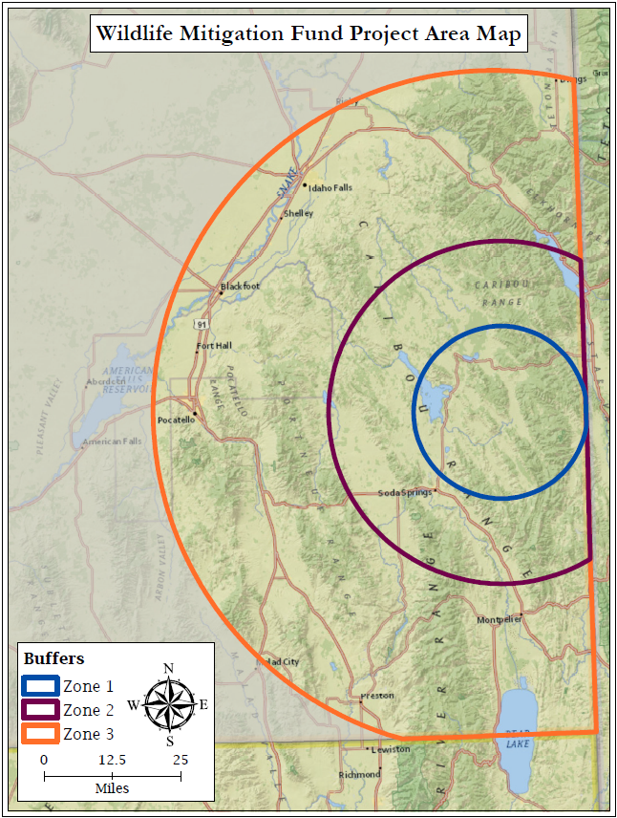

Attachment 2. Project Scoring Matrix (maximum score 175 points).
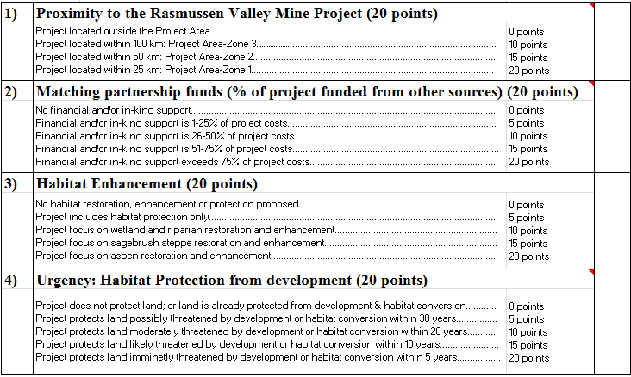
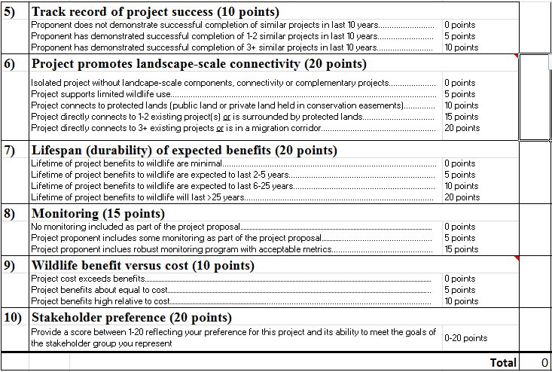
Attachment 3. Timeline.

2020 RFP Timeline
DATE | ACTIVITY
March 20 | Spring HIT Meeting
April 10 | HIT Check-in meeting
April 17 | RFP release and application period opens
May 31 | Deadline for submitting RFP applications
June 05 | Distribute RFP applications to HIT members for scoring with matrix. Post summary of all applications on website
June 25 | First round of HIT scoring & evaluations: Time & location TBD
June 26 | Applicants will be notified of the status of their application. Applicants that remain in consideration will be invited to give a presentation to the HIT on July 09. Presentations must be prepared in a way that can be shared via video conference.
July 09 | Presentations from applicants to HIT and follow-up questions: Time & locations TBD.
July 13-17 | Site visits for 2020 proposals: Time & locations TBD.
By early Aug. | HIT meeting to select project(s) for funding awards. Time & location TBD.
By early Aug. | Applicants will be notified of the status of their application. Successful applicants will receive a grant agreement with instructions for reporting and project completion.

